Machine Learning

CSE 8673

Programming Assignment 2

**Student**: Anh Do

**NetID**: aqd14

# Part A: Deliverables

Please include in your project write up the following plots and answers to questions

1. Plot of raw data

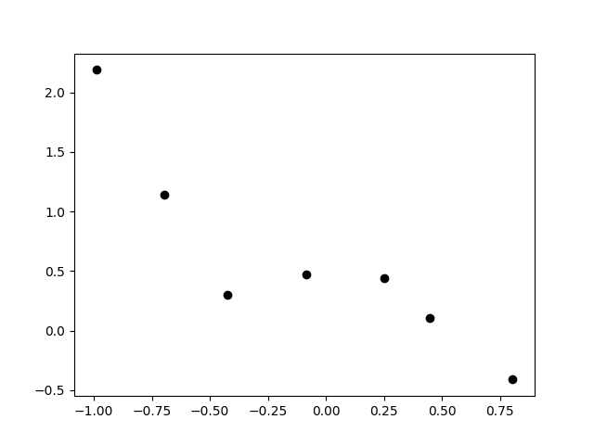

Figure . Plot raw data for part A

2. For each different λ value (3 required, 3 you choose), report:

(a) What value of θ did you get?

|  |  |
| --- | --- |
| **Lambda** | **Theta** |
| 0 | [ 0.49917479 0.83306615 -2.03845857 -6.93424088 3.39424083 5.75306609] |
| 1 | [ 0.38106374 -0.43781896 0.12880159 -0.43609185 0.1933533 -0.37688109] |
| 5 | [ 0.46756365 -0.28432857 0.09426909 -0.23548116 0.1184942 -0.20138849] |
| 10 | [ 0.51357264 -0.19100471 0.06437106 -0.15400044 0.07903144 -0.13137918] |
| 100 | [ 0.59266179 -0.02738086 0.00936885 -0.02153072 0.01125834 -0.01832202] |
| 1,000,000 | [ 6.05801478e-01 -2.87490404e-06 9.85392959e-07 -2.25426435e-06  1.18128378e-06 -1.91774687e-06] |

(b) What is the L2-norm of the θ value you got?

|  |  |
| --- | --- |
| **Lambda** | **L2-norm** |
| 0 | 9.889430 |
| 1 | 0.850345 |
| 5 | 0.646834 |
| 10 | 0.592964 |
| 100 | 0.594148 |
| 1,000,000 | 0.605801 |

(c) A plot of the learned function. These could all be on the plot.

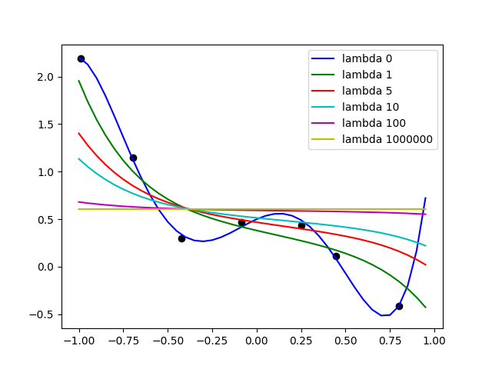

Figure . Plot of learned model with different lambda

(d) Discuss how well you expect this θ to generalize to other data points drawn from the same distribution. (We don’t have other data, so this will be based on what you think the entire distribution will look like)

**Answer**: The θ with λ = 0 will probably suffer from overfitting problem. The machine learning model is somewhat complex and only works by memorizing the seen training data. See **3c** for more details.

3. Answer the following questions:

(a) How the regularization parameter λ affects your model?

**Answer:** Regularization parameter λ adjust the complexity of the machine learning model by penalizing our weights vector (i.e., by using L2-norm).

(b) What would our model look like as λ → ∞?

**Answer:** When λ → ∞, our thetas vector values become extremely small. Therefore, our model becomes a linear function of bias.

(c) What λ do you think results in the model that will generalize the best?

**Answer:** For chosen lambda value, I think the model with λ = 1 will generalize the best. The model with λ = 0 faces the overfitting problem because it only memorizes the training data. The model with λ = 1 almost matches with some training data but also be curving enough to predict the previously unseen data. Other lambda values suffer from underfitting.

# Part B: Deliverables

Please include in your project write up the following plots and answers to questions

1. Plot of raw data

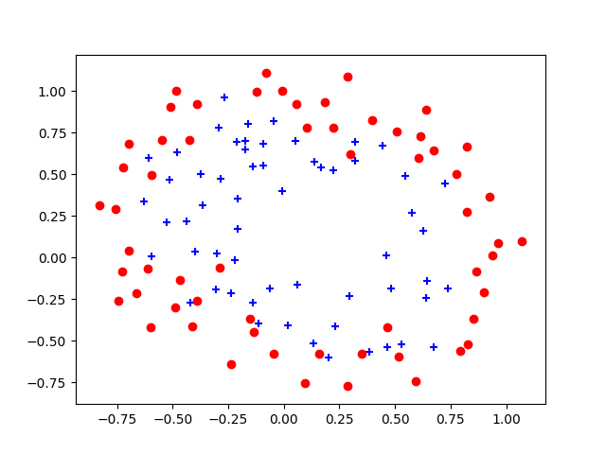

2. For each λ value (3 required, 3 you choose), please report:

* What was the L2-norm of the θ values you got?
* What values of θ did you get?
* How many iterations were required for convergence?
* Plot of final decision boundary found
* What does this model output for an input of (0.5, 0.5)?

**Answer:**

|  |  |  |  |  |
| --- | --- | --- | --- | --- |
| **Lambda** | **L2-norm** | **Iterations** | **Theta** | **Output** |
| 0 | 7301.097590 | 16 | 27.04247528 19.82536158 68.94141094 -323.10507475  -158.16441326 -108.60656083  -132.96913484 -492.61726783  -406.58660701 -363.03142451 1318.61571797 1384.19893953 1381.09959651 584.07341975 276.6374887 351.98491848  1118.55333839 1416.69770844 1675.23155955 1128.91948372 606.88766459 -1506.60749207  -2343.61431421 -3424.25359631  -3192.12272451 -2670.0856728  -1307.90297298 -522.34199678 | 1 |
| 1 | 4.245714 | 5 | 1.32241821 0.71137181 1.19220868  -1.99133437 -0.92146984 -1.51861566  0.12805279 -0.37247721 -0.41142477 -0.1658268 -1.47651984 -0.0528076  -0.64895942 -0.27608993 -1.20705105 -0.27541198 -0.20896745 -0.06394606  -0.28104152 -0.3124246 -0.44554571 -1.07948128 0.0260809 -0.30720874  0.01552269 -0.33790573 -0.14510699 -0.91950837 | 0.677492 |
| 5 | 1.565187 | 4 | 5.52959564e-01 1.12060394e-01 3.50893311e-01 -7.58372612e-01  -2.15950575e-01 -4.93599665e-01 -5.60269648e-02 -1.06696603e-01  -1.19935434e-01 -1.35328958e-01 -5.67910332e-01 -2.22606478e-02  -2.12359874e-01 -5.49706765e-02 -4.70921406e-01 -1.61132815e-01  -6.73816069e-02 -3.66259610e-02 -8.71742596e-02 -7.93511031e-02  -2.70210496e-01 -4.22396095e-01 -2.53043970e-03 -1.04442736e-01  1.04778842e-04 -1.13010359e-01 -2.40404359e-02 -4.25906303e-01 | 0.560497 |
| 10 | 0.940065 | 4 | 3.48390005e-01 9.87871398e-03 1.63730352e-01 -4.43951809e-01  -1.10600451e-01 -2.89727235e-01 -6.75598999e-02 -5.98131907e-02  -6.76169068e-02 -1.07578810e-01 -3.38441852e-01 -1.32292014e-02  -1.20233033e-01 -2.69183994e-02 -2.90035454e-01 -1.17875949e-01  -3.80689126e-02 -2.35923965e-02 -4.97740854e-02 -4.21632552e-02  -1.87485489e-01 -2.56961251e-01 -3.38417324e-03 -5.94689634e-02  -4.00667308e-04 -6.50143643e-02 -1.12331303e-02 -2.73187585e-01 | 0.528019 |
| 100 | 0.126803 | 3 | 0.03946607 -0.01475491 0.00486043 -0.05472123 -0.01289358 -0.0399837  -0.01764224 -0.00804877  -0.00892722 -0.02336593 -0.04344499 -0.00235626 -0.01452437 -0.00326997  -0.04217347 -0.0209109 -0.00486706 -0.00363217 -0.00647767 -0.00494631 -0.03242649 -0.03438026 -0.0011188 -0.00716899 -0.00035226 -0.0081638 -0.00137826 -0.04159813 | 0.497500 |
| 1,000,000 | -0.017094 | 2 | -1.70878689e-02 -1.86579240e-06 6.80307556e-08 -5.64175603e-06  -1.35406925e-06 -4.29198097e-06 -2.01189155e-06 -8.68650822e-07  -9.45448884e-07 -2.69841464e-06 -4.51508266e-06 -2.68833002e-07  -1.50437457e-06 -3.51400850e-07 -4.55141344e-06 -2.28682285e-06  -5.14986936e-07 -3.92341452e-07 -6.88052793e-07 -5.13016227e-07  -3.60055197e-06 -3.59942632e-06 -1.34220796e-07 -7.40374674e-07  -4.61658323e-08 -8.53798260e-07 -1.49696628e-07 -4.51420875e-06 | 0.495727 |

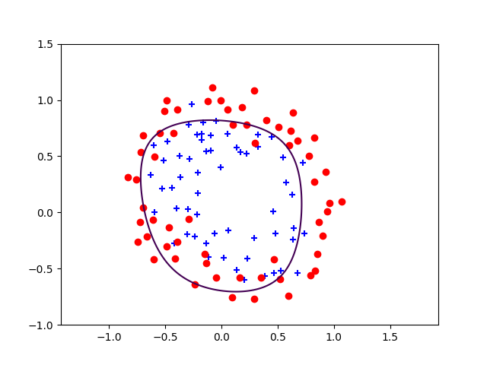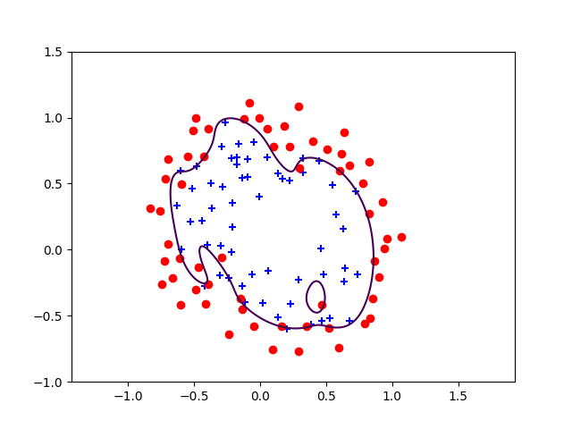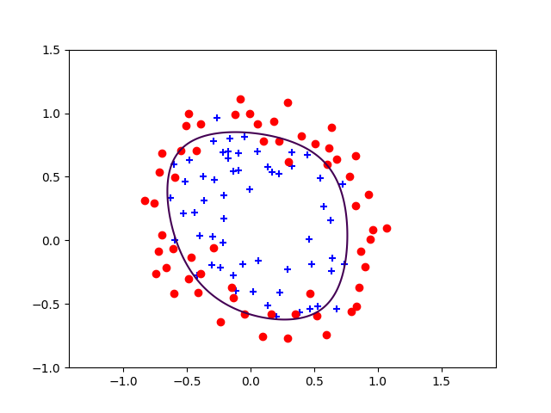

λ = 0

λ = 1

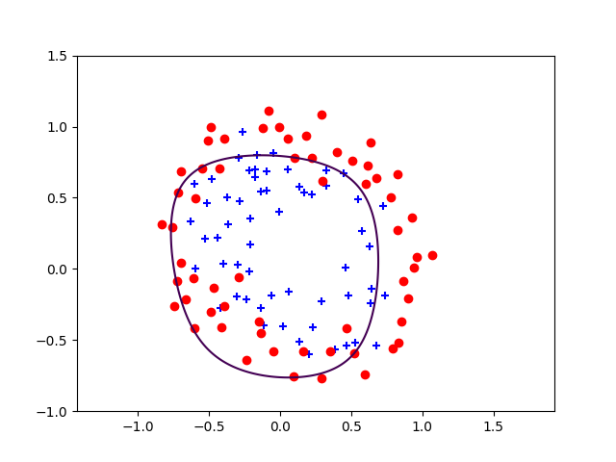

λ = 5

λ = 10

λ = 10

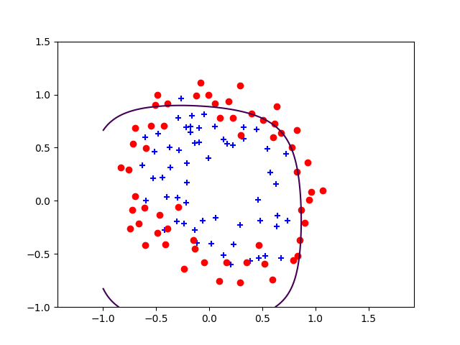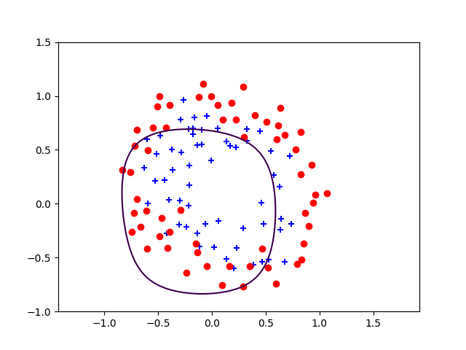

λ = 1,000,000

λ = 100

3. What happens to the decision boundary as λ is increased?

**Answer**: when λ is increased, it becomes more difficult to classify input data. When it gets to 1,000,000 the decision boundary even can’t be completed

4. What value of λ appears to give the best decision boundary (in terms of

generalization)?

**Answer:** It looks like with λ = 1 we have the best decision boundary. It contains least wrong classification (except the model with λ = 0, which is overfitting).

5. Be sure to include in your .pdf submission your code that you wrote for

this assignment.

# Appendix

## Part A

**regulalized_linear_regression.py**

*'''*

*Created on Sep 17, 2017*

*@author: doquocanh-macbook*

*'''*

**import** **numpy** **as** **np**

**from** **numpy.linalg** **import** inv, norm

*# from mpl_toolkits.mplot3d import Axes3D*

**import** **matplotlib.pyplot** **as** **plt**

X = np.loadtxt('pa2data/ax.dat')

y = np.loadtxt('pa2data/ay.dat')

*# print(X)*

*# print(y)*

plt.scatter(X, y, facecolors='black')

*# plt.show()*

*# number of training data*

m = X.shape[0]

*# increase model capacity by adding higher polynomial*

X = np.stack((np.ones(m), X, X**2, X**3, X**4, X**5), axis=-1)

*# number of feature*

n = X.shape[1]

diagonal_matrix = np.diag(np.ones(n))

diagonal_matrix[0][0] = 0

_lambdas = np.array([0, 1, 5, 10, 100, 1000000])

thetas = []

**for** i **in** range(_lambdas.size):

theta = inv(X.T.dot(X) + _lambdas[i] * diagonal_matrix)

theta = theta.dot(X.T)

theta = theta.dot(y)

thetas.append(theta)

*# calculate norm for thetas*

**for** i **in** range(len(thetas)):

**print**('Lambda = **%d** **\t** L2-norm = **%f**' % (_lambdas[i], norm(thetas[i])))

*# input value range*

r = np.arange(-1,1,0.05)

features = np.stack((np.ones(r.shape[0]), r, r**2, r**3, r**4, r**5), axis=-1)

*# plot data*

colors = ['b', 'g', 'r', 'c', 'm', 'y']

**for** i **in** range(_lambdas.size):

**print**(thetas[i])

plt.plot(r, features.dot(thetas[i]), color=colors[i], label='lambda ' + str(_lambdas[i]))

plt.legend(loc='upper right')

plt.show()

## Part B

**regulazied_logistic_regression.py**

*'''*

*Created on Sep 19, 2017*

*@author: aqd14*

*'''*

**import** **numpy** **as** **np**

**import** **matplotlib.pyplot** **as** **plt**

**from** **numpy.linalg** **import** inv, norm

**from** **map_features** **import** *

**def** newton_method(X, y, _lambda, tolerance=1e-5, max_iters=20):

theta = np.zeros((X.shape[1], 1))

epoch = 1

**for** _ **in** range(max_iters):

H = regularized_hessian(X, theta, _lambda)

*# print(hes)*

g = regularized_gradient(X, y, theta, _lambda)

*# print('Gradient shape: ', g.shape)*

temp = theta - np.dot(inv(H), g)

**if** np.sum(abs(theta - temp)) < tolerance:

**print**('Convergered at epoch **%d**' % epoch)

**break**

theta = temp

epoch += 1

**if** epoch >= max_iters:

**print**('Reached maximum iteration!')

**return** theta

**def** regularized_gradient(X, y, theta, _lambda):

m = X.shape[0]

h = hypothesis(X, theta)

g = (1.0/m) * X.T.dot(h-y)

*# Adjust result with regularization parameter*

g[1:] += (_lambda * theta[1:])/m

**return** g

**def** regularized_hessian(X, theta, _lambda):

m = X.shape[0]

h = hypothesis(X, theta)

h.shape = (len(h),)

H = (1.0/m) * np.dot(np.dot(X.T, np.diag(h)), np.dot(np.diag(1-h), X))

*# Adjust result with regularization parameter*

reg_diag_matrix = np.diag(np.ones(X.shape[1]))

reg_diag_matrix[0][0] = 0

H += (_lambda * reg_diag_matrix)/m

**return** H

**def** sigmoid(z):

result = 1.0/(1.0+np.exp(-z))

**return** result

**def** regularized_cost_function(X, y, theta, _lambda):

*"""Calculate cost function with sigmoid activation function and regularization*

*Parameters*

*----------*

*X : array-like*

*Training input data*

*y : array-like*

*Training output data*

*"""*

m = X.shape[0]

h = hypothesis(X, theta)

J = (_lambda * theta[1:]**2)/(2*m) + (1.0/m) * (-y.dot(np.log(h)) - (1-y).dot(np.log(1-h)))

**return** J

**def** hypothesis(X, theta):

*# print('Hypothesis: ', h.shape)*

**return** sigmoid(X.dot(theta))

**def** main():

*# Load dataset*

X = np.loadtxt('pa2data/bx.dat', delimiter=',')

y = np.loadtxt('pa2data/by.dat')

*# Find indices of positive and negative examples*

pos = np.nonzero(y)[0]

neg = np.where(y==0)[0]

*# Plot out the raw data*

*'''*

*plt.scatter(X[pos, 0], X[pos, 1], marker="+", color="b")*

*plt.scatter(X[neg, 0], X[neg, 1], marker="o", color="r")*

*plt.show()*

*'''*

*# Define the ranges of the grid*

u = np.linspace(-1, 1.5, 200)

v = np.linspace(-1, 1.5, 200)

*# Reshape to be 2-D*

u.shape = (len(u), 1)

v.shape = (len(v), 1)

*# Plotting*

X_axis, Y_axis = np.meshgrid(u, v)

Z = np.zeros((len(u), len(v)))

*# Prepare data for Newton method*

*# Create more features for our training data with feature mappings*

X_added_features = map_features(X[:, 0],X[:,1])

*# m = X.shape[0]*

*# X = np.column_stack((np.ones((m, 1)), X))*

y.shape = (y.shape[0], 1)

_lambdas = np.array([0, 1, 5, 10, 100, 1000000])

test_data = map_features(np.array([0.5]), np.array([0.5]))

**for** t **in** range(_lambdas.size):

theta = newton_method(X_added_features, y, _lambdas[t])

**print**('Theta value = **%s\n**' % theta[:,0])

**print**('Lambda = **%d** **\t** L2-norm = **%f\n**' % (_lambdas[t], norm(theta)))

**print**('Prediction value for input (0.5, 0.5) is **%f**' % hypothesis(test_data, theta))

**print**('------------- END ---------------')

**for** i **in** range(len(u)):

**for** j **in** range(len(v)):

Z[i][j] = np.dot(map_features(u[i], v[j]), theta)

plt.clf()

plt.scatter(X[pos,0], X[pos,1], marker='+', color='b')

plt.scatter(X[neg,0], X[neg,1], marker='o', color='r')

plt.axis('equal')

plt.contour(X_axis, Y_axis, Z.T, 0, linewidth=2)

plt.show()

**if** __name__ == '__main__':

main()